**LAB 8**

**OBJECTIVE**

To be familiar with the thinning morphological operation

**THEORY**

Thinning is a morphological operation that is used to remove selected foreground pixels from binary images, somewhat like erosion or opening. It can be used for several applications, but is particularly useful for skeletonization. In this mode it is commonly used to tidy up the output of edge detectors by reducing all lines to single pixel thickness. Thinning is normally only applied to binary images, and produces another binary image as output.

It is the transformation of a digital image into a simplified, but topologically equivalent image. It is a type of topological skeleton, but computed using mathematical morphology operators.

**CODE**

% Program 1 : Thinning Image

image=imread('image.jpg');

image1=rgb2gray(image);

figure;imshow(image);title('Original Image');

% Noise Removal

image_denoised=medfilt2(image1);

% Remove corner pixels

image_denoised=image_denoised(2:end-1,2:end-1);

figure;imshow(image_denoised);title('Denoised Image');

% Image Transformation

% Image Transformation by discrete fourier transform

gamma=1;low_in=0;high_in=1;low_out=1;high_out=0;

image_transformed = imadjust(image_denoised,

[low_in high_in],[low_out high_out],gamma);

figure;imshow(image_transformed);title('Transformed Image');

% Image Binarization

% Otsu's method for finding global threshold

threshold=graythresh(image_transformed);

image_binarized= im2bw(image_transformed, threshold);

figure;imshow(image_binarized);title('Binarized Image');

% Block Filter

image_thinned=bwmorph(image_binarized,'thin','Inf');

figure;imshow(image_thinned);title('Thinned Image');

**OUTPUT**

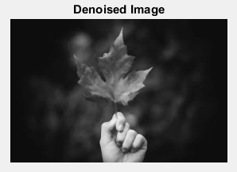

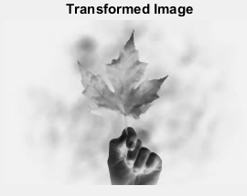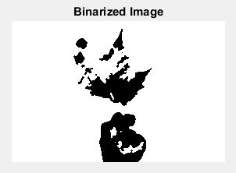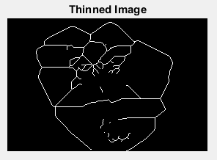

**CONCLUSION**

In this lab, I got familiar with thinning morphological operation and tested it in an image.